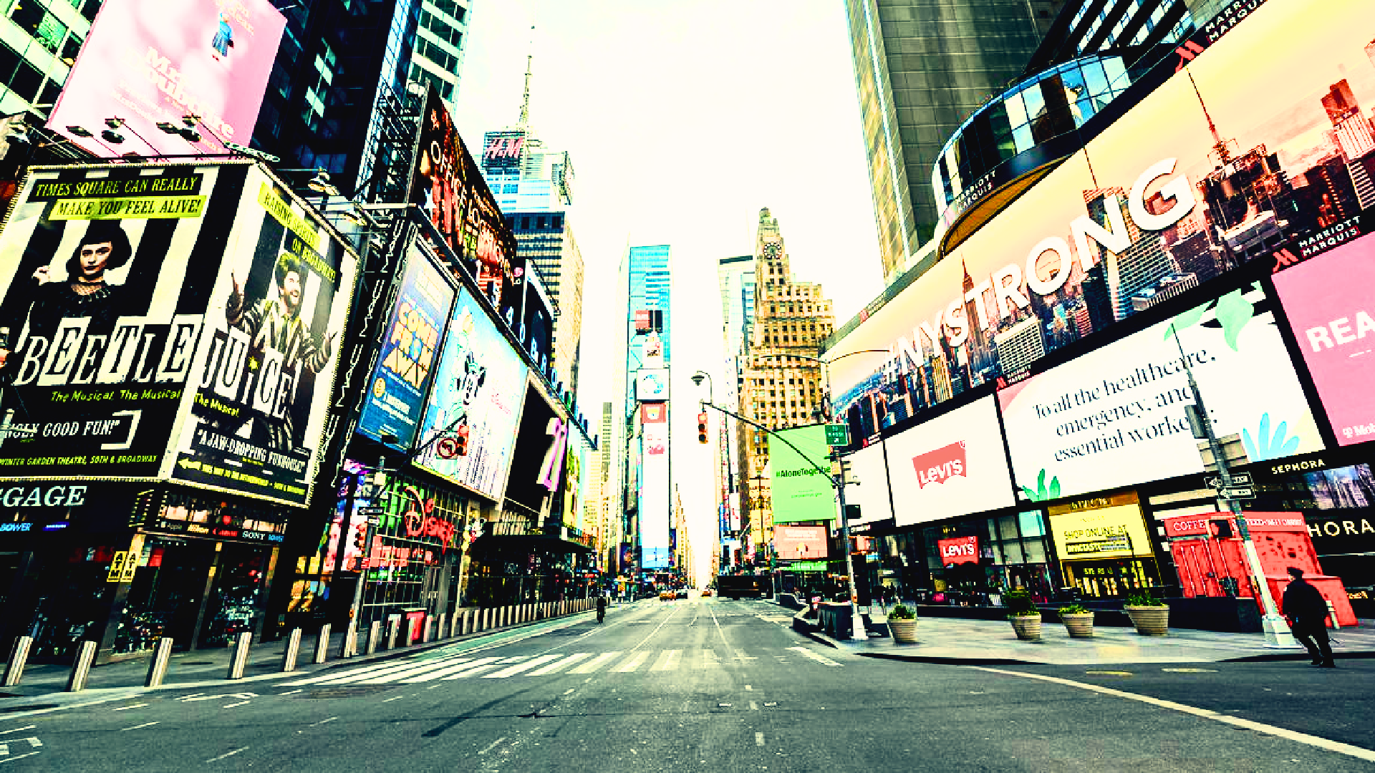





April 22, 2025 | Earth and Water Day Concert
September 21, 2025 | International Day of Peace and Climate Week Kick-Off






Agenda
Overview of 2025 Events Participants
Partner and City Agencies

Broadcast Partner Success Sponsorship Packages Event Production Details
About Good News Corporation & Production Partners


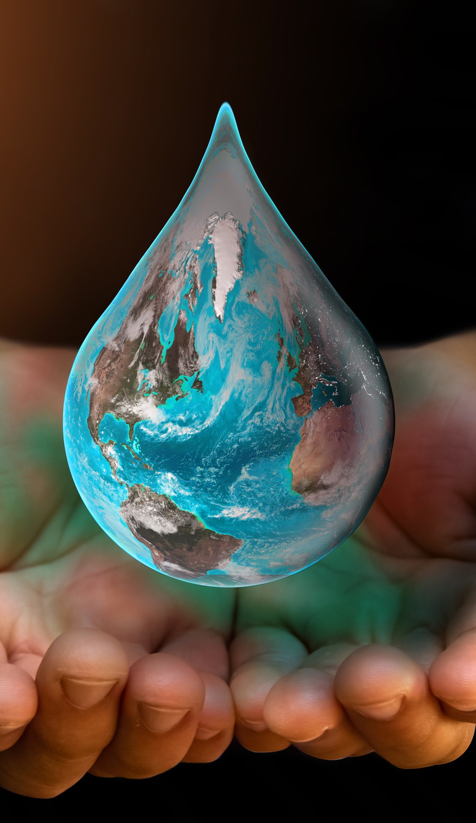

Overview of 2025 Events

Earth and Water Day Concert (April 22, 2025)
Addressing global environmental challenges: flooding, hurricanes, fires, earthquakes, tornadoes, and polluted water and skies. 2024 Earth Day Sizzle https://pausetheworldforpeace.org/2024/08/31/earth-day-4-22-224-sizzle-reel-times-square/
World event in partnership with Borough President Manhattan, OMMM, www.EarthDay.org and other leading environmental and entertainment organizations and individuals that live and breathe to care about Mother Earth and Climate Concerns

International Day of Peace (September 21, 2025)
23rd Annual Good News International Day of Peace, 46th Annual UN International Day of Peace. 2024 Peace Day Sizzle: https://pausetheworldforpeace.org/2024/10/31/sizzle-reel-2024-international-day-of-peace-climate-week-kick-off/
UN General Assembly & 193 countries declaring this as a day devoted to strengthening the ideals of peace through observing 24 hours of non-violence, cease-fire and Acts of PEACE.
Kicks off Climate Week NYC, run by Climate Group, largest of the organization's annual flagship international events.

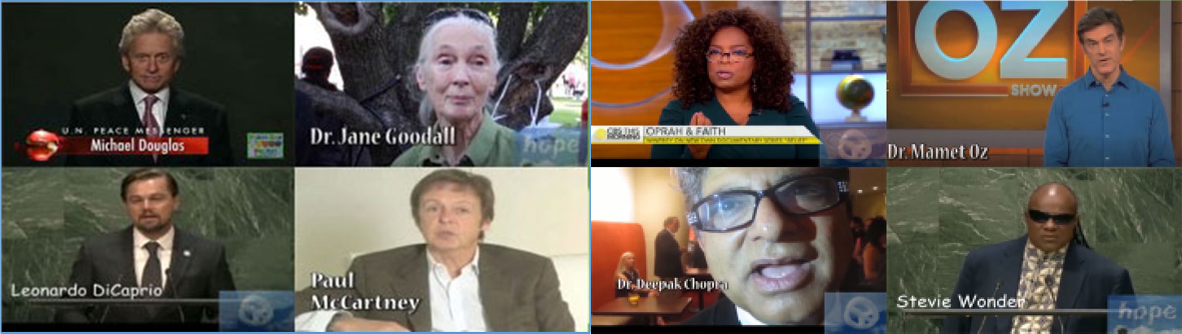
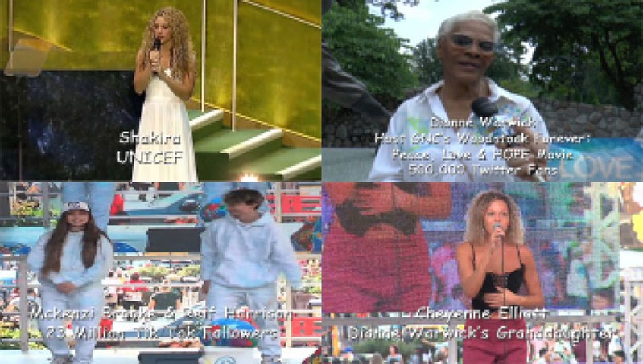
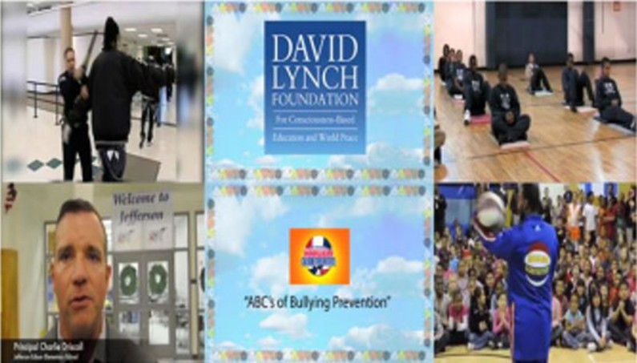
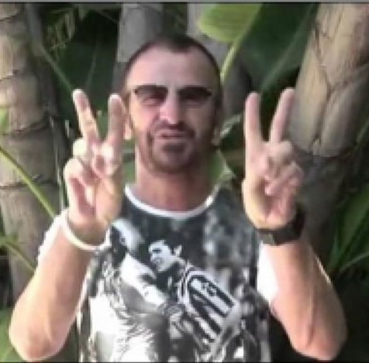
Peace Messengers, Dignitaries, Participants in the Broadcasts

Special Note:
Ringo Starr requests a global moment of silence at 12 noon on Earth & Water Day and the International Day of Peace.


Partner and City Agencies

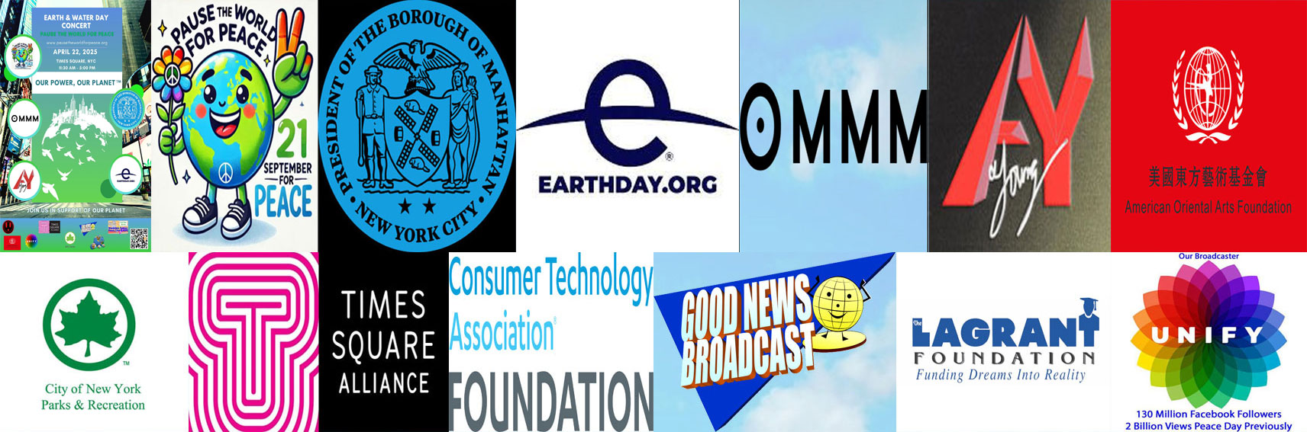
Join the Corporations who have participated in and supported our events

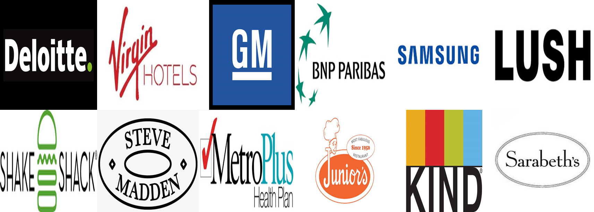

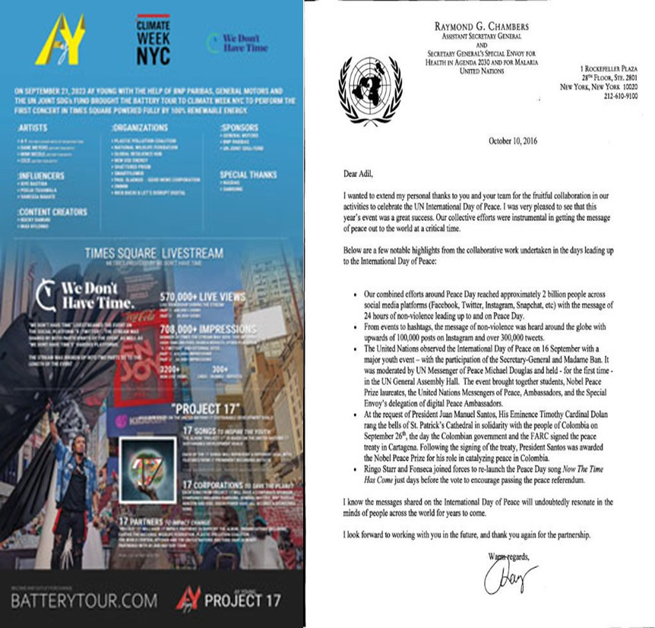
Some of Our Broadcast Partners Success

YouTube Analytics for www.youtube.com/goodnewsbroadcast (July 28, 2024 – November 1, 2024)

913,939 Impressions

2024 Peace Day AY Young Performance
Reached 938,209,200 Impressions


Sponsorship Packages

All Sponsorship titles can receive:
Inclusion in PR campaigns, and group signage on the Stage and on the Step and Repeat
Title Funder will be mentioned at the show broadcast.
First-right-of-refusal for celebrity concert on September 20, 2025 at the Centennial Memorial Theater TBD.
Certificates for Earth & Water Day and for the International Day of Peace.

Special Note:
5% of the total amount will go to a nonprofit charity, representing activities whose efforts foster CSR, ESG, and DEI (LAGRANT Foundation selected for DEI and Consumer Technology Association part of CES for CSR), and ESG nonprofit TBD, or selection open to corporations.)



Sponsorship Packages
SILVER
$50K one event / $80K both
BRONZE
$20K one event / $32K both


events - 20% discount
GOLD
$125K one event / $200K both
events - 20% discount
events - 20% discount

45-minute
speaking/performing slot.
1-minute commercial with your message at the beginning and end of each broadcast.
Recognition by
www.pausetheworldforpeace. org,www.goodnewsplanet.TV, www.9-21.org
10-minute
speaking/performing slot.
15-second commercial with your message at the beginning and end of each broadcast.
Recognition by
www.pausetheworldforpeace. org,www.goodnewsplanet.TV, www.9-21.org
5-minute
speaking/performing slot.
7-second commercial with
your message at the beginning and end of each broadcast.

Event Production Details

Production Schedule for April 22, 2025 and September 21, 2025


Set up Time: 2 AM Fine Quality Events Stage with LED Screen
Set up Time: 5 AM Production truck, cameras, jib risers
Set up Time: 7 AM Talent Green Room & VIP Area
Tents for sponsors,
food, and VIP tents and chairs will be ready.
Live Broadcast & Event Kick-off: TBD

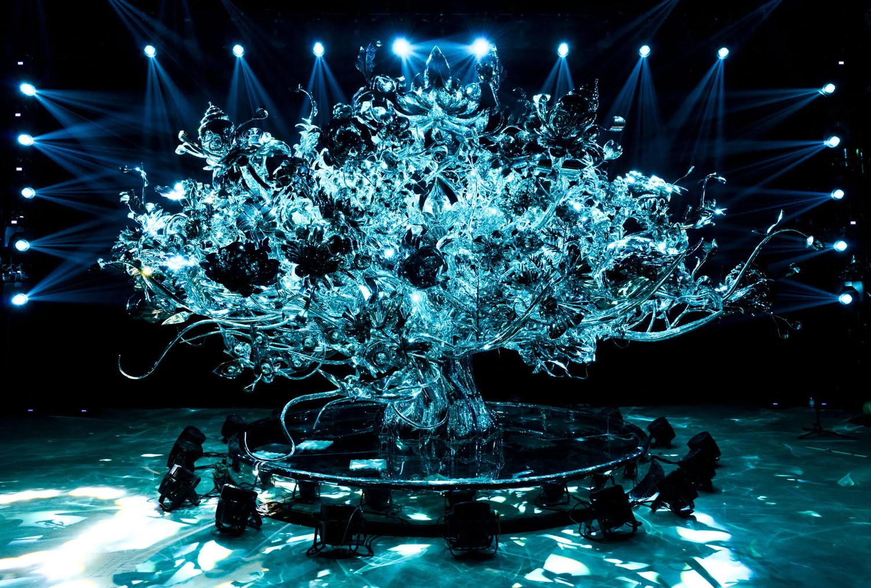
THE PEACE FRIENDSHIP TREE

Details:

26.3 ft wide
10 ft tall
14 ft depth
forged with over 271 workers 29,275 stainless steel parts for over 5 years
craftspeople from USA and China

The Peace Friendship Tree will appear in Father DuUffy Square from September 21 to 22, 2025 with 12 International Models standing beside it.

About Good News Corporation

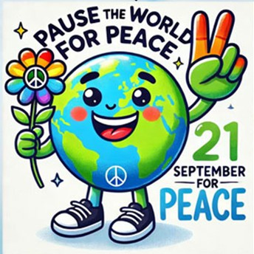
Good News Credentials:
501(c)(3) nonprofit, established in 2002
Mission: Create and promote life-affirming, thought-provoking, non-violent content across TV, radio, podcasts, social media, print, video games, and events
Producers of International Day of Peace concerts in Central Park, Times Square, and Silicon Valley since 2002
Partnership with UNIFY for Peace Day broadcast, reaching over 2 billion views Collaboration with We the World and their 11 Days of Global Unity initiative,
established in 2002

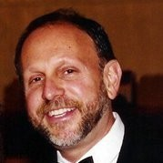
Founder: Paul Sladkus
Former CBS/PBS production executive
Involved in over 150 Emmy-winning TV shows, including All in the Family, Sonny and Cher, Carol Burnett, Love of Life, PBS’s Nature and Brain Series

City Partners, Co-Producer & Partners with Good News Corporation

Manhattan Borough President Mark Levine - President Levine joins us for the second year. Mark has been a concerned and actionable environmentalist for many years.
President Levine shares the same missions with Good News Corporation for Peace and Care for Mother Earth.
https://www.manhattanbp.nyc.gov/about-mbpo/bp-mark-levine/https://www.manhattanbp.nyc.gov/about-mbpo/bp-mark-levine/

OMMM - Co-Producer - At the core, OMMM is a beautiful and powerful manifestation of its founders’ genuine desire to make the world a better place. Through content, events, transformation
programs and immersive experiences, OMMM amplifies the powerful work of our OMMMambassadors, a network of incredible human beings and organizations who support the expansion of our
mission to enhance global well-being, unlock our full potential, and actively contribute to a more peaceful society. www.ommmpresents.com

earthday.org - Partner - EARTHDAY.ORG's mission is to diversify, educate and activate the environmental movement worldwide. Growing out of the first Earth Day in 1970,
EARTHDAY.ORG is the world’s largest recruiter to the environmental movement, working with more than 150,000 partners in over 192 countries to drive positive action for our
planet.

AY Young - Partner - Every now and then, the right vision, the right energy, and the right story meet to create something unique and world-changing. This is AY Young. Founder of
the revolutionary Battery Tour (with over 800 solar-powered concerts performed), eclectic musician and inspired activist, he is the United Nations Young Leader for the SDGs, on a
mission to break barriers and build bridges. https://www.aymusik.com/

Milestone Broadcast Corporation (MBC): Est. 1985. Strong relationships with leading public relations firms, MBC’s extensive global connections in multicultural, niche, and
general media. Full-service multicultural marketing and production firm. Clients: Citibank, IBM, Delta Airlines, Sprint, US Postal Service, and Western Union. Produced over 6,000 broadcasts on platforms like GoodNewsPlanet.tv , YouTube.com/GoodNewsBroadcast & PausetheWorldforPeace.org. MBC works with seasoned pros. XStream Broadcasting,
Fine Quality Events, World Star PR, American Oriental Arts Foundation, and others who are known as the best in the business.

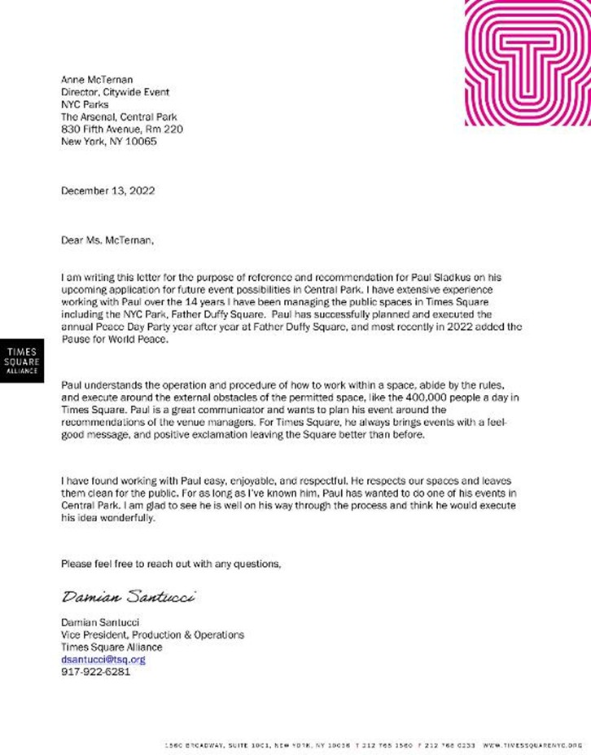

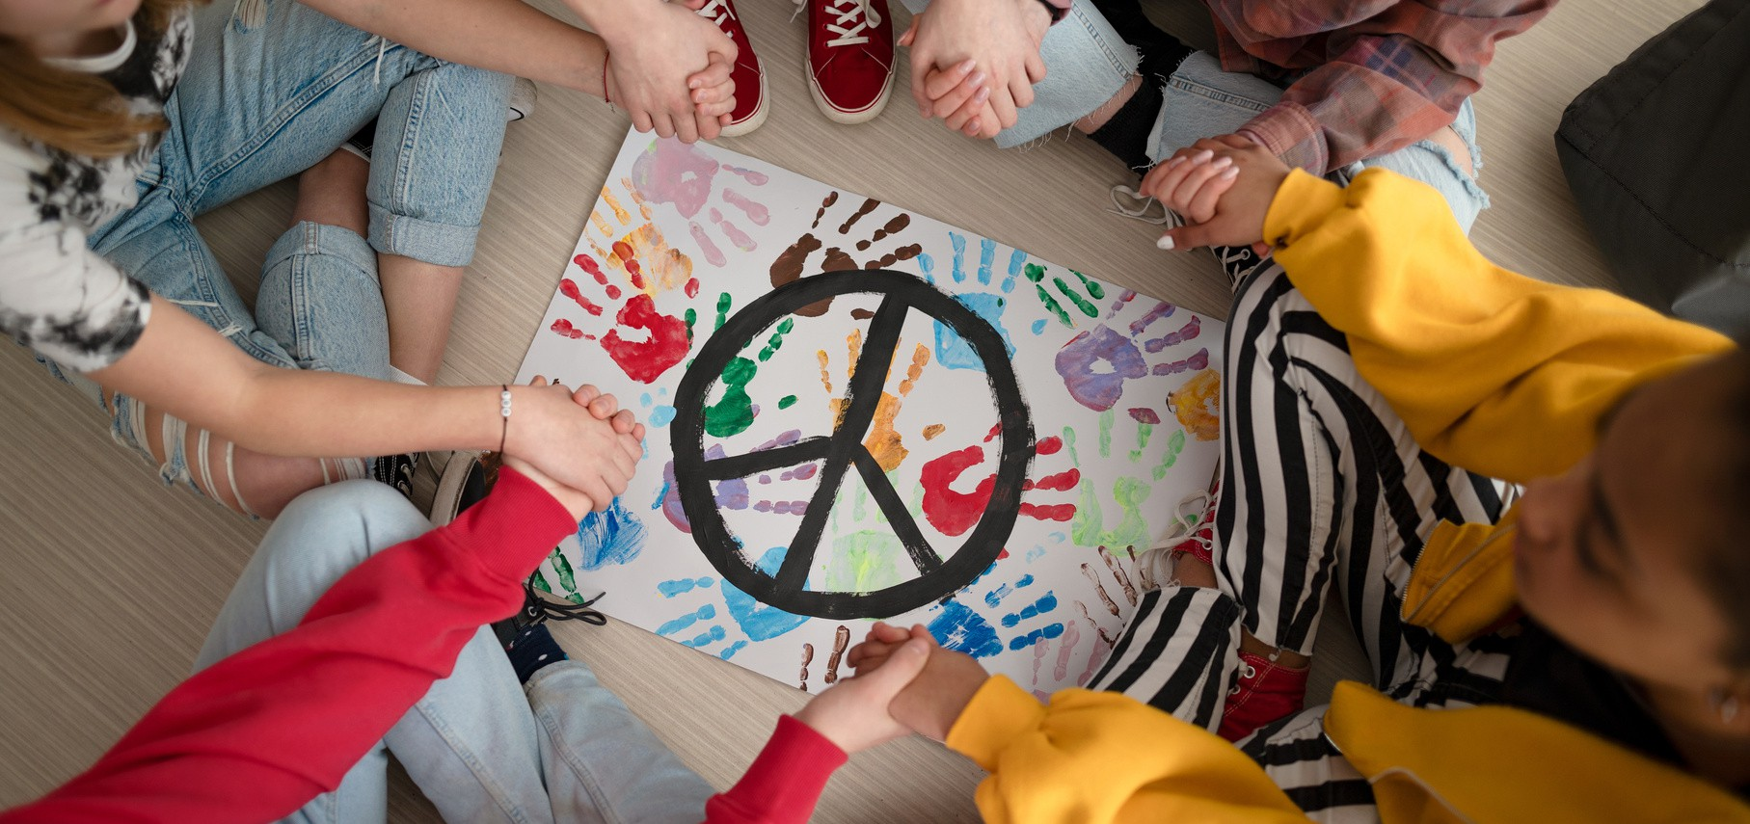
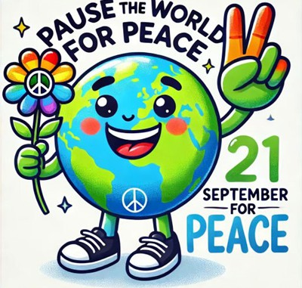
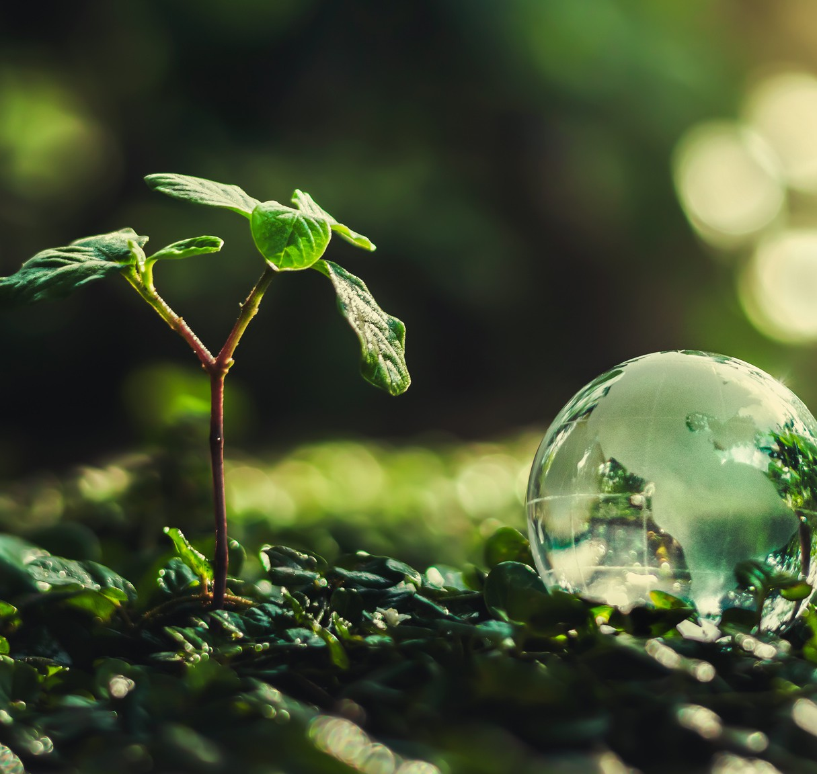

Thank You!

Moment of Silence Worldwide Earth & Water Day | April 22, 2025

International Day of Peace and Climate Week Kick-Off | September 21, 2025

*Good News Corporation, 501c3
Nonprofit, est. 2002

