wE wIN TOGEThER

aLINa BONsELL
CANDIDATE FOR NY STATE SENATE
Alina Bonsell is a Yorkville resident, mother, and small business owner, not a career politician. In 1989, her family immigrated to the United States as Jewish refugees from the Soviet Union when she was a small child. She has spent her life building businesses and fighting to stay afloat in a city that is increasingly hostile to the people who make it run.

With 20 years of experience in pharmaceutical operations and private sector leadership, including roles in regulatory affairs, executive management, and complex systems oversight, Alina brings a track record of
She is running because she is tired of excuses. This campaign is personal. Alina is fighting for a safer, cleaner, and fairer New York for families, small business owners, and everyday residents who just want stability. She is not running to play the political game. She is running to expose what is broken and fix it.

ALINA’S PRIORITIES
 Improve Eastside Public Safety
End wasteful government spending
Tax relief for young adults G new parents
Protect Jewish Safety with Stronger Legislation Family Court Reform

ABOUT THE RACE
District 28 covers Manhattan's East Side from East 14th Street to East 96th Street, including Yorkville, Kips Bay, Murray Hill, Gramercy, Midtown East, and Roosevelt Island. The seat is currently held by incumbent Democrat Liz Krueger, who has represented the district since 2002.

CONTACT
 www.alinabonsell.com

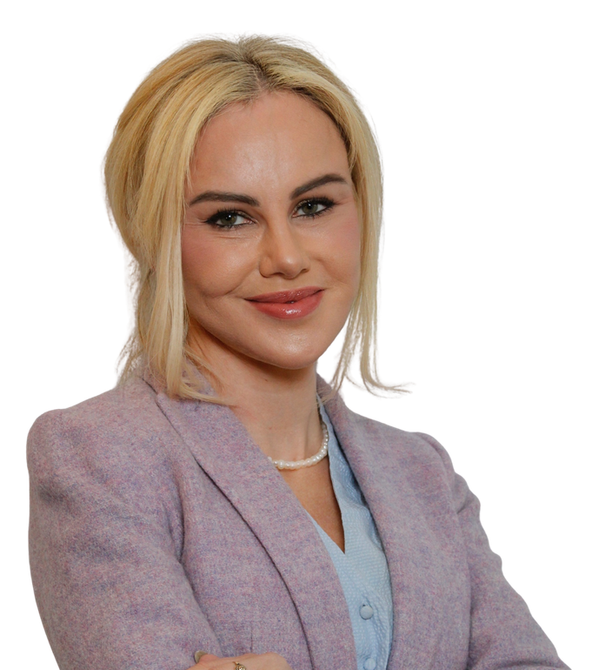
accountability and measurable results. She will bring that same discipline to Albany.
 campaign@alinabonsell.com  alinab.nyc
 alinabonsell
ALINa
BONSELL
NEW YORK STATE SENATE

